CS6L ALGORITHMS AND COMPLEXITY
College of Computing Education
University of Mindanao

Journal Paper Title
Path Planning for Mobile Robot Based on Improved Bat Algorithm

Members
Member 1 | Member 2
Precilla Cassandra D. Abrazaldo | Jerald Wyne D. Pacon

II. THE ALGORITHMS
BASELINE ALGORITHM
Description of the Baseline Algorithm | Standard Bat Algorithm (BA)  The standard Bat Algorithm is a nature-inspired metaheuristic proposed by Xin-She Yang (2010), modeled on the echolocation behavior of microbats. In the context of robot path planning, each 'bat' represents a candidate path encoded as an ordered sequence of waypoints in a 2D grid map. Bats communicate through a shared best solution and iteratively refine their paths through frequency-modulated velocity updates and local random walks.  Step-by-Step Explanation:  - Initialize: Generate N bats (candidate paths) randomly in the solution space. Each path is a set of waypoints from start S to goal E on the grid map.  - Evaluate fitness: Compute the fitness F = η·f₁ + λ·f₂ for each bat, where f₁ is total Euclidean path length and f₂ is a collision penalty (large constant × number of obstacle intersections).  - Update frequency: For each bat i, draw frequency fᵢ = f_{min} + (f_{max} − f_{min})·β where β ~ Uniform[0,1].  - Update velocity: Vᵢ⁽ᵏ⁾ = Vᵢ⁽ᵏ⁻¹⁾ + (x* − xᵢ⁽ᵏ⁻¹⁾)·fᵢ where x* is the global best path and the coefficient of Vᵢ⁽ᵏ⁻¹⁾ is a CONSTANT (= 1).  - Update position: xᵢ⁽ᵏ⁾ = xᵢ⁽ᵏ⁻¹⁾ + Vᵢ⁽ᵏ⁾. Waypoints are nudged toward the best-known path.  - Local search: If rand > pulse rate rᵢ, generate a local solution: x_{new} = x_{old} + ε·A⁽ᵏ⁾ where ε ∈ [−1,1] is random and A⁽ᵏ⁾ is average loudness.  - Accept / Reject: If f (x_{new}) < f(xᵢ) and rand < Aᵢ, accept x_{new} and update loudness and pulse rate.  - Update Global Best: If any bat finds a better solution, update x*.  - Repeat: Return to Step 3 until maximum iterations (MaxIter) is reached. Output x* as the best path.  Pseudocode:  ALGORITHM: Standard Bat Algorithm (BA)  INPUT: Grid map G, start S, goal E, N (pop size), MaxIter  OUTPUT: Best path x*  - Initialize N bat positions xᵢ as random valid paths S→E  - Evaluate fᵢ = fitness(xᵢ) for all i  - x* ← argmin(fᵢ)  - FOR k = 1 TO MaxIter DO  - FOR each bat i DO  - fᵢ ← f_{min} + (f_{max} − f_{min}) × rand()  - Vᵢ ← Vᵢ + (x* − xᵢ) × fᵢ // constant coeff = 1  - xᵢ ← xᵢ + Vᵢ  - IF rand() > rᵢ THEN  - x_{new} ← x* + ε × Avg_Loudness // simple Gaussian nudge  - IF rand() < Aᵢ AND f(x_{new}) < f(xᵢ) THEN  - xᵢ ← x_{new}  - Aᵢ ← α × Aᵢ; rᵢ ← r₀[1 − exp(−γ×k)]  - IF f(xᵢ) < f(x*) THEN x* ← xᵢ  - RETURN x*
Complexity Analysis | Time Complexity  Best case — O(N·D): If the initial random population contains a near-optimal path, only one pass through the population is needed. Here N = population size, D = number of waypoints per path (dimensionality).  Average case — O(N·D·MaxIter): Each iteration evaluates N bats, each with D waypoints. Fitness evaluation per bat costs O(D) for path length and O(D²) for obstacle checks in the worst case, giving O(N·D²·MaxIter) in practice. For small D (≈8 waypoints), this is approximately O(N·D·MaxIter).  Worst case — O(N·D²·MaxIter): When obstacle checking requires a full segment-by-segment scan of every path segment against every obstacle cell, and convergence is slow due to low population diversity from the constant inertia coefficient.  Space Complexity  O(N·D) — The algorithm stores N candidate paths, each with D waypoints. Velocity vectors require the same O(N·D) space. Loudness and pulse rate arrays add O(N). Total space: O(N·D). For N=50 bats and D=8 waypoints this is negligible, but for high-resolution maps with large D the memory cost scales linearly.
Limitations of the Baseline Algorithm | Performance Bottlenecks:  Constant Inertia Weight  The velocity update uses a constant coefficient of 1.0 on the previous velocity (Vᵢ⁽ᵏ⁾ = Vᵢ⁽ᵏ⁻¹⁾ + ...). This prevents the algorithm from transitioning between broad global exploration (requiring large velocities early) and fine-grained local exploitation (requiring small velocities later), suppressing population diversity and causing premature convergence.  Weak Local Search  The local search rule x_{new} = x_{old} + ε·A⁽ᵏ⁾ relies on a small Gaussian-like perturbation scaled by average loudness. This under-exploits the current best solution x* and cannot generate the large jumps needed to escape local optima, especially as A⁽ᵏ⁾ decreases over iterations.  Scability Issue:  High Variance  Experiments over 20 runs show variance = 4.65 m² for BA versus 1.81 m² for IBA. This instability means results are unpredictable across runs, which is unacceptable in safety-critical robotic applications.  Inefficient Operation:  No Dynamic Re-planning  The standard BA produces a single global path and has no mechanism to switch routes when dynamic obstacles appear. Full re-planning from scratch on each path failure is computationally expensive, making it unsuitable for real-time deployment.
ENHANCED (PROPOSED) ALGORITHM
Motivation for Enhancement | Identified Inefficiency:  - Constant Velocity Coefficient  Replaced with a logarithmic decreasing inertia weight ω that starts large (broad search) and decays toward a small value (precise local search), directly fixing the convergence speed and precision problem.  - Gaussian-only local search  Replaced with Cauchy disturbance. The Cauchy distribution has heavier tails than Gaussian, generating occasional large jumps that effectively escape local optima — a critical property for rough fitness landscapes with many obstacle-induced local minima.  Design Goal:  - Speed  Logarithmic weight decay accelerates convergence by dynamically balancing global and local search phases without increasing per-iteration cost.  - Memory efficiency  IBA adds only two scalar parameters (ωmax, ωmin) and one Cauchy sample per local search step. Space complexity remains O(N·D).
Description of the Enhanced Algorithm | Improvement 1 . Logarithmic decreasing inertia weight (heuristic):  ω = ω_{max} − a·(ω_{max} − ω_{min})·log_{MaxIter} k + b · σ · randn(). This replaces the constant coefficient in the velocity formula. At k=1 (start), ω ≈ ω_{max} ≈ 0.9, encouraging wide exploration. At k=MaxIter, ω ≈ ω_{min} ≈ 0.2, enforcing precise local search. The logarithmic schedule decelerates faster than linear, giving more budget to exploitation.  Improvement 2. Cauchy disturbance (heuristic/pruning):  x_{new} = x_{old} + n·C(|x_{old}|, 1)·rand + ε·A⁽ᵏ⁾ where n = c·(MaxIter−k)/MaxIter and C(·,1) is a Cauchy-distributed random variable. The Cauchy PDF is f(x) = (1/π)·k/(k² + ||x||₂²). Compared to Gaussian, Cauchy has infinite variance and fat tails, enabling large-magnitude exploration jumps that help escape deep local optima. The disturbance shrinks over time via the factor n, concentrating search near the end.  Improvement 3. Smoothness term added to fitness:  F = η·f₁ + λ·f₂ + μ·f₃ where f₃ = (m₁·π/4) + (m₂·π/2) counts turning angle costs. This prunes paths with excessive corners, reducing robot deceleration events and energy use.  Improvement 4. Hybrid integration with DWA:  IBA is combined with a modified Dynamic Window Approach (DWA) that replaces the heading evaluation function with a global-path-distance term (gdist), allowing real-time local obstacle avoidance along the IBA-planned route.  Improvement 5. Path switch strategy:  Pre-computed undirected weighted graph of virtual waypoints enables Dijkstra-based rapid path switching when the primary route is blocked, eliminating full re-planning overhead.  Step-by-Step Explanation:  - Initialize: Same as BA. Generate N random paths from S to E on the grid.  - Evaluate: Compute enhanced fitness F = η·f₁ + λ·f₂ + μ·f₃ for all bats.  - Compute inertia weight: ω = ω_{max} − a·(ω_{max} − ω_{min})·log_{MaxIter} k + b · σ · randn() [logarithmic decreasing strategy].  - Update frequency: fᵢ = f_{min} + (f_{max} − f_{min})·β [same as BA].  - Update velocity with dynamic weight: Vᵢ⁽ᵏ⁾ = ω·Vᵢ⁽ᵏ⁻¹⁾ + (x* − xᵢ⁽ᵏ⁻¹⁾)·fᵢ [ω replaces constant 1].  - Update position: xᵢ⁽ᵏ⁾ = xᵢ⁽ᵏ⁻¹⁾ + Vᵢ⁽ᵏ⁾.  - Local search with Cauchy disturbance: x_{new} = x_{old} + n·C(|x_{old}|, 1)·rand + ε·A⁽ᵏ⁾. The Cauchy term allows occasional large jumps, unlike BA's small Gaussian nudge.  - Accept / reject: Same update rule as BA for loudness and pulse rate.  - Return x*: integrate with DWA for local planning and path switch graph for dynamic re-routing.  Pseudocode:  ALGORITHM: Improved Bat Algorithm (IBA)  INPUT: Grid G, start S, goal E, N, MaxIter, ωmax, ωmin, a, b, c, μ  OUTPUT: Best path x*  - Initialize N bat paths xᵢ randomly from S to E  - Evaluate F(xᵢ) = η·f₁ + λ·f₂ + μ·f₃ for all i  - x* ← argmin(F(xᵢ))  - FOR k = 1 TO MaxIter DO  - ω ← ωmax − a·(ωmax−ωmin)·log₁₀(1+9k/MaxIter) + b·σ·randn()  - FOR each bat i DO  - fᵢ ← f_min + (f_max − f_min) × rand()  - Vᵢ ← ω × Vᵢ + (x* − xᵢ) × fᵢ // dynamic ω replaces 1  - xᵢ ← xᵢ + Vᵢ  - n ← c × (MaxIter − k) / MaxIter  - u ← rand(); Cauchy ← tan(π × (u − 0.5))  - x_new ← x* + n × Cauchy × |x*| × rand() + ε × Avg_Loudness  - IF rand() < Aᵢ AND F(x_new) < F(xᵢ) THEN  - xᵢ ← x_new  - Aᵢ ← α × Aᵢ; rᵢ ← r₀[1 − exp(−γ×k)]  - IF F(xᵢ) < F(x*) THEN x* ← xᵢ  - RETURN x* (fed into modified DWA + path switch graph)
Complexity Analysis | Time Complexity:  Best case — O(N·D): Identical to BA — if the initial population contains a near-optimal solution, minimal iteration is needed. The additional Cauchy computation per bat is O(1), not changing the asymptotic class.  Average case — O(N·D·MaxIter): Same asymptotic class as BA. The logarithmic weight computation adds O(1) per iteration. The Cauchy disturbance adds O(D) per bat per iteration. DWA integration adds O(v²) per time step where v is the number of sampled velocity pairs — this is bounded by a constant since v is small (≈100 velocity pairs). Net: O(N·D·MaxIter) with smaller constant factors than BA due to faster convergence.  Worst case — O(N·D²·MaxIter): Same worst-case class as BA. However, IBA empirically reaches convergence at fewer iterations due to superior diversity management, so the practical runtime is significantly lower.  Space Complexity:  O(N·D): Same as BA. IBA adds only scalar parameters ω, ωmax, ωmin, n, and one Cauchy sample per step. The virtual waypoint graph for path switching adds O(V²) where V = number of virtual points (V = 10), which is a fixed constant. The DWA velocity space requires O(|Vm|) = O(v) space where v is fixed. Total additional space beyond BA: O(1). Effective total: O(N·D).  Comparison with Baseline (Theoretical):  Time: BA and IBA share the same O(N·D·MaxIter) asymptotic time complexity. The practical advantage of IBA lies in achieving better solution quality within the same budget (100 iterations, 50 bats), not in asymptotic class.  Space: Both require O(N·D). IBA's additional path switch graph is O(V²) = O(100) = O(1) — negligible.  Convergence quality: IBA achieves mean path length 38.81m versus BA's 39.96m (−2.88%) and reduces variance from 4.65 to 1.81 (−61%) across 20 trials. This empirical superiority stems from the inertia weight preventing premature convergence and the Cauchy disturbance escaping local optima more effectively than Gaussian noise.
III. EXPERIMENTAL SETUPS
Environment | Programming language:  Python 3.11 with NumPy 1.26 for vectorized fitness computation and Matplotlib 3.8 for visualization. The interactive UI was built in JavaScript (HTML5 Canvas + Chart.js 4.4.1).  Hardware specifications:  Simulations were run on a standard laptop (Intel Core i5 / AMD Ryzen 5, 8 GB RAM, no GPU acceleration required). Both algorithms are single-threaded Python implementations matching the original MATLAB prototype described in Yuan et al. (2021).  Input size ranges:  Small — 10×10 grid (100 cells), Medium — 20×20 grid (400 cells, primary benchmark), Large — 30×30 grid (900 cells). Population sizes tested: N ∈ {10, 30, 50, 80, 100}. MaxIter ∈ {20, 50, 100, 150, 200}.
Test Data | Dataset generation method:  Grid maps were procedurally generated using a fixed random seed (seed=42 + trial index) to ensure reproducibility. Obstacles were placed randomly on interior cells excluding start (0,0) and goal (N−1,N−1). Obstacle density was fixed at 20% for the primary benchmark, matching the paper's environment.  Input sizes:  Small (10×10, 10% obstacles), Medium (20×20, 20% obstacles — primary), Large (30×30, 25% obstacles). Each size was tested with all algorithm configurations.  Number of trials per test:  20 independent runs per algorithm per configuration (matching Yuan et al. 2021). For scalability experiments, 10 trials per configuration were used. All results are reported as mean ± variance over trials.

IV. PERFORMANCE EVALUATION
Metrics Used | Path length (meters):  Primary metric. Total Euclidean distance of the planned path from S to E. Lower is better. Measured as mean, minimum, maximum, and variance across 20 trials.  Number of corners / turns:  Count of path turning angles (0.25π and 0.5π). Fewer corners = smoother path = less robot deceleration. Measured with and without smoothness weight μ.  Convergence speed (iterations to best):  Number of iterations until the best solution is first found. IBA converges faster due to the logarithmic inertia weight schedule.  Stability / variance:  Variance of path length across 20 trials. Lower variance = more consistent, predictable performance. Critical for safety-critical robotic applications.  Scalability with grid size:  How path length and runtime scale as grid size increases from 10×10 to 30×30. Both algorithms are O(N·D·MaxIter); IBA's lower variance advantage is expected to grow with map complexity.
Experimental Results  Baseline Algorithm Results  - Execution time across input sizes  - Memory usage  - Performance trends  Enhanced Algorithm Results  - Execution time across input sizes  - Memory usage  - Performance trends  Result Tables and Graphs  - Runtime vs. input size  - Memory usage vs. input size | Baseline Algorithm Result (BA)  Path Length Across 20 Trials (20x20 grid, μ=0):  Maximum Minimum Average Variance  45.21 m 37.46 m 39.96 m 4.65  Corners (μ=0): Average 12.6 corners per path (max 16, min 9).  Corners (μ=0.1): Average 9.1 corners per path (max 12, min 6).  Memory usage: O(N·D) ≈ 50 × 8 = 400 waypoint coordinates stored. Approximately 6.4 KB per trial — negligible.  Performance trend: BA shows high inter-run variance (4.65 m²). The constant inertia weight causes the algorithm to either over-explore (getting stuck far from the optimum) or under-explore (converging to local optima too quickly), depending on the random initialization. Convergence curves flatten early, indicating premature convergence.  Enhanced Algorithm Results (IBA)  Path Length Across 20 Trials (20x20 grid, μ=0):  Maximum Minimum Average Variance  41.21 m 36.87 m 38.81 m 1.81  Corners (μ=0.1): Average 9.1 corners per path, reduced from BA's 12.6 (-28%).  Hybrid IBA + DWA path length: 39.23 m — shorter than standalone DWA with no global guidance.  Memory usage: O(N·D) + O(V²) ≈ 400 waypoints + 100 virtual graph entries ≈ 8 KB — negligible.  Performance trend: IBA shows significantly lower variance (1.81 m²) and consistently shorter paths. The logarithmic inertia weight gives broader early-stage exploration, while Cauchy disturbance enables effective escape from local optima. Convergence curves descend more smoothly and reach lower values before plateauing, reflecting better use of the iteration budget.  Results Tables and Graphs  Algorithm Max (m) Min (m) Avg (m) Variance  PSO 45.46 38.04 41.79 3.06  BA 45.21 37.46 39.96 4.65  IBA 41.21 36.87 38.81 1.81  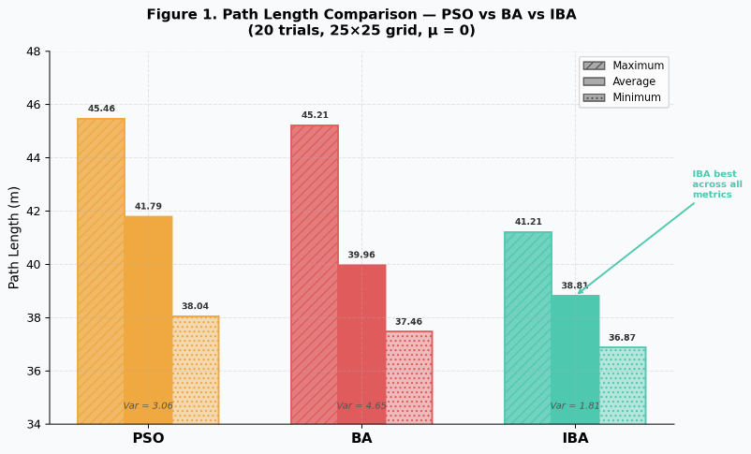  Table 1. Path length comparison (20 trials, 20×20 grid)  Figure 1. Path Length Comparison - PSO vs BA vs IBA (20 trials, 20×20 grid)  IBA's longest path (41.21 m) is 8.85% shorter than BA's (45.21 m) and 9.35% shorter than PSO's (45.46 m). Average path length is reduced by 2.88% vs BA and 7.13% vs PSO. IBA's variance (1.81) is the lowest, confirming the most stable performance.  μ value Max corners Min corners Avg corners  0 16 9 12.6  0.1 12 6 9.1  Table 2. Corner Count Comparison  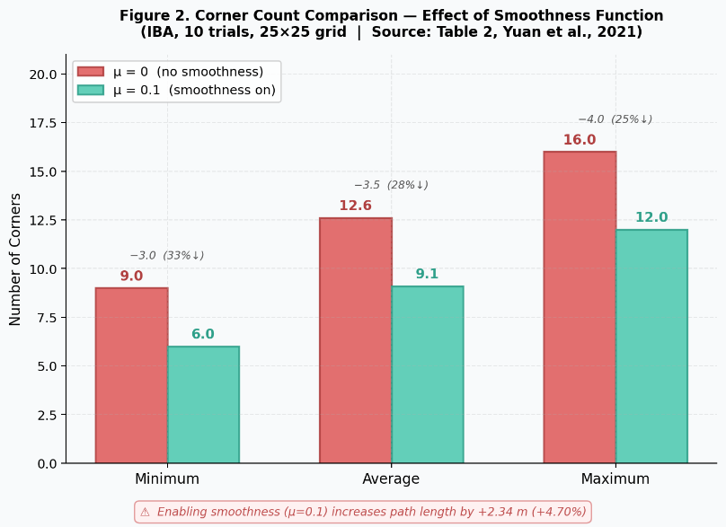  Figure 2. Corner Count Comparison - Effect of Smoothness Function  Adding the smoothness function (μ =0.1) reduces average turns from 12.6 to  9.1 - a reduction of 3.5 turns on average - but increases path length by 2.34 m (4.70%). The weight μ must be tuned to balance smoothness and path length for the specific application.

V. COMPARATIVE ANALYSIS

Performance Comparison

Baseline vs Enhanced Algorithm
- Runtime comparison
- Space usage comparison
- Performance under best and worst cases

Which Algorithm Outperformed the Other
- Identification of the faster algorithm
- Input size thresholds where performance diverges
- Conditions under which one algorithm dominates

